**Client-server based room temperature and lighting control application**

**INTRODUCTION**

Smart room is a building equipped with high technology that allows various systems and devices to communicate with each other. As digital technologies are converging, the field of room automation is expanding. Various smart room control system has been developed including the control system with Blue-tooth, internet, and short message service. Bluetooth capabilities are good equipment with low prices, and it can reduce the cost of the system. However, by using Bluetooth the range of environment is limited, and it is not feasible solution to implement. The Wi-Fi based room automation have proposed with good result. The users can manage and control the system locally (LAN) or remotely (internet). The system supports a wide range of room automation devices like power management components and security components.

The predictive control system is utilized to control temperature and lights in rooms.

o control the lighting system is important, due to

the efficiency of electricity consumption. To turn on and turn off the lights in the

home always use the conventional switch.

o control the lighting system is important, due to

the efficiency of electricity consumption. To turn on and turn off the lights in the

home always use the conventional switch.

o control the lighting system is important, due to

the efficiency of electricity consumption. To turn on and turn off the lights in the

home always use the conventional switch.

Control the lighting and temperature system is important, due to the efficiency of electricity consumption. To turn on and turn off the lights in the room always use the conventional switch.

**UML use case diagram(s):**

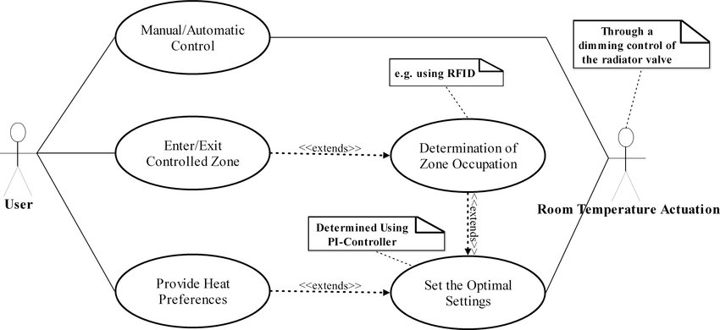

**UML class diagram:**

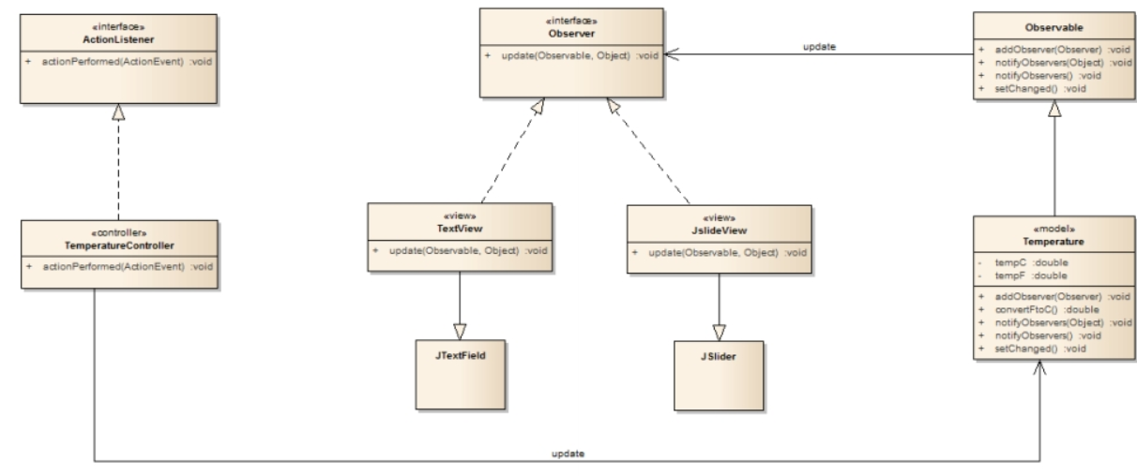

* 1. **Source files ( Server):**

As this system needs to be monitored remotely. So, data needs to be stored somewhere, from where a user or administrator can access. For this purpose, we need a server. The server can be accessed by an IP address and two ports. This access can be done through command prompt.

The data of room temperature and light will be store in a file. The user can access it and define after how much delay the data should be accessed. This function makes this system a real time application. As, the user can have data regarding temperature and light at any time.

The client side consist of three users, an administrator and two other. These three have a single IP and two different ports to access the data at server. Administrator has a IP and a different port number to access the server data. The other two users have a different access to data. One can access temperature data from server. While, the other one can access the data regarding light.

As the administrator have a complete access to server. So, the administrator can stop the communication of data from server to clients, if needed.

In a case, if the server doesn’t receive any further data and it reaches the end of file, then will go to the start of file and will send data to clients continuously.

* 1. ***Clients: temperature controller and light level controller***

In this system we have IP and port numbers for clients. So, clients can connect to server through their IP and ports.

As we have here three types of users, an administrator and two other, one can monitor temperature and other can monitor light. So, after the connection of clients to the server, the server will identify the scope of connected users. If the user is an administrator. Then both temperature and light data will be accessible. If user is the one who is monitoring the temperature data, then temperature data will be accessible. And same for the one monitoring the light.

**For client 1 (temperature controller):**

At the temperature controller side thresholds are defined. So, if the threshold is crossed than the speed of fan will be adjust accordingly.

**For client 2 (light controller):**

At the light controller side level of light and themes are defined. So, the light will be adjusting accordingly.

In case of stopping the monitoring, a stop command will be sent to server and server will stop sending temperature and light data.

In this paper, the webserver used to bridge between the user and the

microcontroller. The command from the user will be entered into a server and it

processed back to the microcontroller, and vice versa. A server is a running instance

of an application (software) capable of accepting requests from the client and giving

responses accordingly. Servers can run on any computer including dedicated

computers, which individually are also often referred to as "the server".

**Documentation (Word/PDF document)** **explaining the steps:**

In this paper, the webserver used to bridge between the user and the

microcontroller. The command from the user will be entered into a server and it

processed back to the microcontroller, and vice versa. A server is a running instance

of an application (software) capable of accepting requests from the client and giving

responses accordingly. Servers can run on any computer including dedicated

computers, which individually are also often referred to as "the server".

In this paper, the webserver used to bridge between the user and the

microcontroller. The command from the user will be entered into a server and it

processed back to the microcontroller, and vice versa. A server is a running instance

of an application (software) capable of accepting requests from the client and giving

responses accordingly. Servers can run on any computer including dedicated

computers, which individually are also often referred to as "the server".

In this paper, the webserver used to bridge between the user and the

microcontroller. The command from the user will be entered into a server and it

processed back to the microcontroller, and vice versa. A server is a running instance

of an application (software) capable of accepting requests from the client and giving

responses accordingly. Servers can run on any computer including dedicated

computers, which individually are also often referred to as "the server".

In this paper, the webserver used to bridge between the user and the

microcontroller. The command from the user will be entered into a server and it

processed back to the microcontroller, and vice versa. A server is a running instance

of an application (software) capable of accepting requests from the client and giving

responses accordingly. Servers can run on any computer including dedicated

computers, which individually are also often referred to as "the server".

In this system, we have used a server for saving data and for the communication of data. The server receive request from client for data of temperature and light, and respond to it, on basis of the access granted to each client.

The client side of this system can be controlled through a mobile phone. As the client side is an android application. The client side can control and monitor the temperature and light through its android application. The client side android application consists of three windows, the first one is a main window, consists of two buttons. On clicking at the room temperature client can monitor temperature and on clicking at light button client can monitor the light.